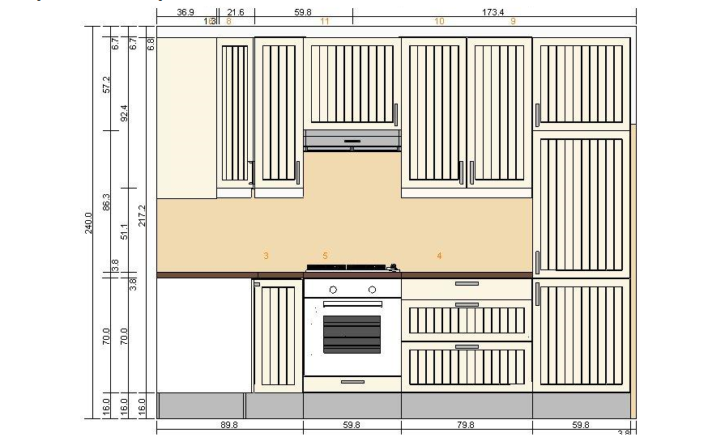

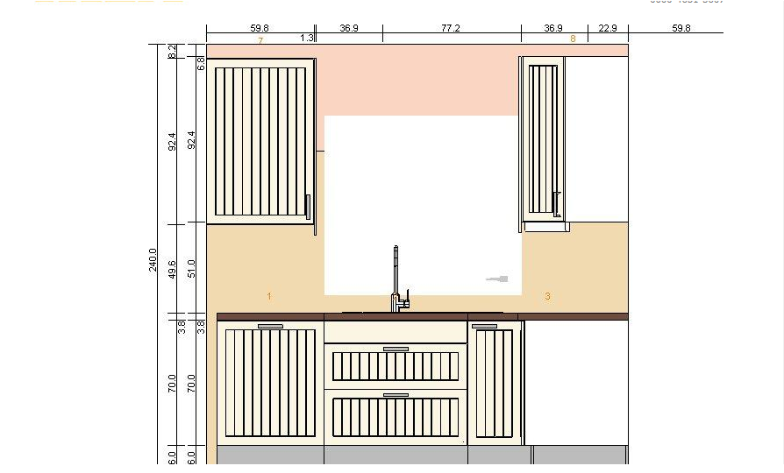

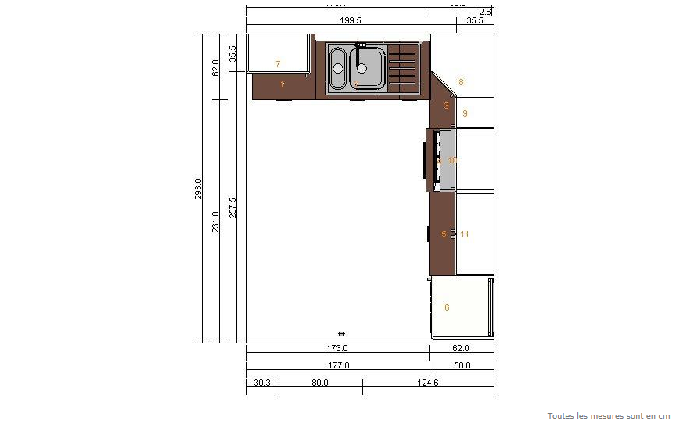

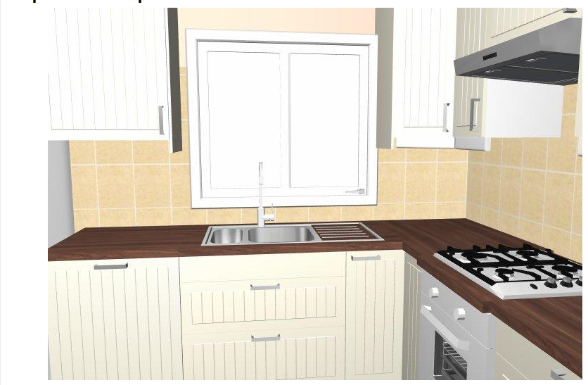

LISTE DES ARTICLES: PLAN REZ1

Fermer

Liste détaillée des articles de votre plan

Numéro de série du plan en cours 0000-4651-3607

|  |  |  |  |  |  |  |  |  |  |  |  |  |  |  |  |  |  |  |  |  |  |  |  |  |  |  |  |  |  |  |  |  |  |  |  |  |  |  |  |  |  |  |  |  |  |  |  |  |  |  |  |  |  |  |  |  |  |  |  |  |  |  |  |  |  |  |  |  |  |  |  |  |  |  |  |  |  |  |  |  |  |  |  |  |  |  |  |  |  |  |  |  |  |  |  |  |  |  |  |  |  |  |  |  |  |  |  |  |  |  |  |  |  |  |  |  |  |  |  |  |  |  |  |  |  |  |  |  |  |  |  |  |  |  |  |  |  |  |  |  |  |  |  |  |  |  |  |  |  |  |  |  |  |  |  |  |  |  |  |  |  |  |  |  |  |  |  |  |  |  |  |  |  |  |  |  |  |  |  |  |  |  |  |  |  |  |  |  |  |  |  |  |  |  |  |  |  |  |  |  |  |  |  |  |  |  |  |  |  |  |  |  |  |  |  |  |  |  |  |  |  |  |  |  |  |  |  |  |  |  |  |  |  |  |  |  |  |  |  |  |  |  |  |  |  |  |  |  |  |  |  |  |  |  |  |  |  |  |  |  |  |  |  |  |  |  |  |  |  |  |  |  |  |  |  |  |  |  |  |  |  |  |  |  |  |  |  |  |  |  |  |  |  |  |  |  |  |  |  |  |  |  |  |  |  |  |  |  |  |  |  |  |  |  |  |  |  |  |  |  |  |  |  |  |  |  |  |  |  |  |  |  |  |  |  |  |  |  |  |  |  |  |  |  |  |  |  |  |  |  |  |  |  |  |  |  |  |  |  |  |  |  |  |  |  |  |  |  |  |  |  |  |  |  |  |  |  |  |  |  |  |  |  |  |  |  |  |  |  |  |  |  |  |  |  |  |  |  |  |  |  |  |  |  |  |  |  |  |  |  |  |  |  |  |  |  |  |  |  |  |  |  |  |  |  |  |  |  |  |  |  |  |  |  |  |  |  |  |  |  |  |  |  |  |  |  |  |  |  |  |  |  |  |  |  |  |  |  |  |  |  |  |  |  |  |  |  |  |  |  |  |  |  |  |  |  |  |  |  |  |  |  |  |  |  |  |
| --- | --- | --- | --- | --- | --- | --- | --- | --- | --- | --- | --- | --- | --- | --- | --- | --- | --- | --- | --- | --- | --- | --- | --- | --- | --- | --- | --- | --- | --- | --- | --- | --- | --- | --- | --- | --- | --- | --- | --- | --- | --- | --- | --- | --- | --- | --- | --- | --- | --- | --- | --- | --- | --- | --- | --- | --- | --- | --- | --- | --- | --- | --- | --- | --- | --- | --- | --- | --- | --- | --- | --- | --- | --- | --- | --- | --- | --- | --- | --- | --- | --- | --- | --- | --- | --- | --- | --- | --- | --- | --- | --- | --- | --- | --- | --- | --- | --- | --- | --- | --- | --- | --- | --- | --- | --- | --- | --- | --- | --- | --- | --- | --- | --- | --- | --- | --- | --- | --- | --- | --- | --- | --- | --- | --- | --- | --- | --- | --- | --- | --- | --- | --- | --- | --- | --- | --- | --- | --- | --- | --- | --- | --- | --- | --- | --- | --- | --- | --- | --- | --- | --- | --- | --- | --- | --- | --- | --- | --- | --- | --- | --- | --- | --- | --- | --- | --- | --- | --- | --- | --- | --- | --- | --- | --- | --- | --- | --- | --- | --- | --- | --- | --- | --- | --- | --- | --- | --- | --- | --- | --- | --- | --- | --- | --- | --- | --- | --- | --- | --- | --- | --- | --- | --- | --- | --- | --- | --- | --- | --- | --- | --- | --- | --- | --- | --- | --- | --- | --- | --- | --- | --- | --- | --- | --- | --- | --- | --- | --- | --- | --- | --- | --- | --- | --- | --- | --- | --- | --- | --- | --- | --- | --- | --- | --- | --- | --- | --- | --- | --- | --- | --- | --- | --- | --- | --- | --- | --- | --- | --- | --- | --- | --- | --- | --- | --- | --- | --- | --- | --- | --- | --- | --- | --- | --- | --- | --- | --- | --- | --- | --- | --- | --- | --- | --- | --- | --- | --- | --- | --- | --- | --- | --- | --- | --- | --- | --- | --- | --- | --- | --- | --- | --- | --- | --- | --- | --- | --- | --- | --- | --- | --- | --- | --- | --- | --- | --- | --- | --- | --- | --- | --- | --- | --- | --- | --- | --- | --- | --- | --- | --- | --- | --- | --- | --- | --- | --- | --- | --- | --- | --- | --- | --- | --- | --- | --- | --- | --- | --- | --- | --- | --- | --- | --- | --- | --- | --- | --- | --- | --- | --- | --- | --- | --- | --- | --- | --- | --- | --- | --- | --- | --- | --- | --- | --- | --- | --- | --- | --- | --- | --- | --- | --- | --- | --- | --- | --- | --- | --- | --- | --- | --- | --- | --- | --- | --- | --- | --- | --- | --- | --- | --- | --- | --- | --- | --- | --- | --- | --- | --- | --- | --- | --- | --- | --- | --- | --- | --- | --- | --- | --- | --- | --- | --- | --- | --- | --- | --- | --- | --- | --- | --- | --- | --- | --- | --- | --- | --- | --- | --- | --- | --- | --- | --- | --- | --- | --- | --- | --- | --- | --- | --- | --- | --- | --- | --- | --- | --- | --- | --- | --- | --- | --- | --- | --- | --- | --- | --- | --- | --- | --- | --- | --- | --- | --- | --- | --- | --- | --- | --- | --- | --- | --- | --- | --- | --- | --- |
| Prix total: € 3.232,31   |  |  |  |  |  | **Prix** | **Quantité** | **Prix total** | | --- | --- | --- | --- | --- | --- | --- | --- | |  |  |  | | | | | | |  | | http://www.ikea.com/PIAimages/0208036_PE361991_S1.JPG | 10248345 | LAGAN lave-vaisselle intégré A  blanc | € 299,00 | 1 | € 299,00 | |  | | | | | |  |  |  |  |  |  |  |  |  | | --- | --- | --- | --- | --- | --- | --- | --- | | 1 |  |  | | | | | | |  | | http://www.ikea.com/PIAimages/76404_PE195938_S1.jpg | 30150583 | STÅT façade pour lave-vaisselle  blanc cassé  60x70 cm | € 50,00 | 1 | € 50,00 | | http://www.ikea.com/PIAimages/21883_PE106857_S1.jpg | 04375085 | FIXA pare-vapeur  chromé | € 5,50 | 1 | € 5,50 | |  | | | | | |  |  |  |  |  |  |  |  |  | | --- | --- | --- | --- | --- | --- | --- | --- | | 2 |  |  | | | | | | |  | | http://www.ikea.com/PIAimages/0101795_PE245722_S1.JPG | S59867508 | FA 168 FAKTUM élement évier avec tiroirs/2 faces  Ståt blanc cassé  80 cm | € 215,00 | 1 | € 215,00 | | http://www.ikea.com/PIAimages/0104330_PE251297_S1.JPG | 30169318 | RATIONELL plateau anti-fuite | € 8,00 | 1 | € 8,00 | | http://www.ikea.com/PIAimages/0151725_PE309838_S1.JPG | 70227236 | UTRUSTA ouverture à pression, électrique | € 99,00 | 1 | € 99,00 | | http://www.ikea.com/PIAimages/81985_PE207264_S1.JPG | 80140577 | RINGSKÄR mitigeur  blanc | € 75,00 | 1 | € 75,00 | | http://www.ikea.com/PIAimages/74391_PE191376_S1.jpg | S09896283 | BOHOLMEN évier enc 1 1/2 bac avec égouttoir  acier inoxydable  90x50 cm | € 130,00 | 1 | € 130,00 | |  | | | | | |  |  |  |  |  |  |  |  |  | | --- | --- | --- | --- | --- | --- | --- | --- | | 3 |  |  | | | | | | |  | | http://www.ikea.com/PIAimages/0088653_PE220064_S1.JPG | S09854297 | FA 159 FAKTUM élément bas angle+rgt pivotant  Ståt blanc cassé  90x90 cm | € 200,00 | 1 | € 200,00 | |  | | | | | |  |  |  |  |  |  |  |  |  | | --- | --- | --- | --- | --- | --- | --- | --- | | 4 |  |  | | | | | | |  | | http://www.ikea.com/PIAimages/28914_PE115803_S1.jpg | S49809359 | FA 122 FAKTUM élément bas pour four  Ståt blanc cassé  60 cm | € 64,00 | 1 | € 64,00 | | http://www.ikea.com/PIAimages/0103017_PE248785_S1.JPG | 20152196 | LAGAN OV3 four  blanc | € 129,00 | 1 | € 129,00 | | http://www.ikea.com/PIAimages/0094556_PE241593_S1.JPG | 90154173 | DÅTID HGA4K table de cuisson à gaz  blanc cassé  58x50 cm | € 229,00 | 1 | € 229,00 | |  | | | | | |  |  |  |  |  |  |  |  |  | | --- | --- | --- | --- | --- | --- | --- | --- | | 5 |  |  | | | | | | |  | | http://www.ikea.com/PIAimages/27188_PE113268_S1.jpg | S39836594 | FA 113 FAKTUM élément bas 3 tiroirs  Ståt blanc cassé  80 cm | € 226,00 | 1 | € 226,00 | |  | | | | | |  |  |  |  |  |  |  |  |  | | --- | --- | --- | --- | --- | --- | --- | --- | | 6 |  |  | | | | | | |  | | http://www.ikea.com/PIAimages/29504_PE116857_S1.jpg | S09809832 | FA 707 FAKTUM armoire réfrig/congélateur+3 portes  Ståt blanc cassé  60x233/57 cm | € 202,00 | 1 | € 202,00 | | http://www.ikea.com/PIAimages/0189718_PE343718_S1.JPG | 70245551 | RÅKALL réfrigérateur/congél encast A+  blanc  162/72 l | € 449,00 | 1 | € 449,00 | |  | | | | | |  |  |  |  |  |  |  |  |  | | --- | --- | --- | --- | --- | --- | --- | --- | | 7 |  |  | | | | | | |  | | http://www.ikea.com/PIAimages/29569_PE117005_S1.jpg | S99811086 | FA 311 FAKTUM élément mural  Ståt blanc cassé  60x92 cm | € 87,00 | 1 | € 87,00 | |  | | | | | |  |  |  |  |  |  |  |  |  | | --- | --- | --- | --- | --- | --- | --- | --- | | 8 |  |  | | | | | | |  | | http://www.ikea.com/PIAimages/0087803_PE217602_S1.JPG | S69852479 | FA 347 FAKTUM élément angle mural+rgt pivotant  Ståt blanc cassé  60x92 cm | € 120,00 | 1 | € 120,00 | |  | | | | | |  |  |  |  |  |  |  |  |  | | --- | --- | --- | --- | --- | --- | --- | --- | | 9 |  |  | | | | | | |  | | http://www.ikea.com/PIAimages/29569_PE117005_S1.jpg | S99811010 | FA 308 FAKTUM élément mural  Ståt blanc cassé  30x92 cm | € 56,00 | 1 | € 56,00 | |  | | | | | |  |  |  |  |  |  |  |  |  | | --- | --- | --- | --- | --- | --- | --- | --- | | 10 |  |  | | | | | | |  | | http://www.ikea.com/PIAimages/32286_PE118249_S1.jpg | S59810480 | FA 337 FAKTUM élément surhotte  Ståt blanc cassé  60x57 cm | € 58,00 | 1 | € 58,00 | | http://www.ikea.com/PIAimages/0206476_PE360571_S1.JPG | 60244670 | LAGAN hotte aspirante murale  acier inoxydable  60 cm | € 69,90 | 1 | € 69,90 | |  | | | | | |  |  |  |  |  |  |  |  |  | | --- | --- | --- | --- | --- | --- | --- | --- | | 11 |  |  | | | | | | |  | | http://www.ikea.com/PIAimages/29936_PE117701_S1.jpg | S79810969 | FA 313 FAKTUM élément mural 2 portes  Ståt blanc cassé  80x92 cm | € 128,00 | 1 | € 128,00 | |  | | | | | |  |  |  |  |  |  |  |  |  | | --- | --- | --- | --- | --- | --- | --- | --- | |  |  |  | | | | | | |  | | http://www.ikea.com/PIAimages/32640_PE122663_S1.jpg | 50076318 | FAKTUM pied  noir  16 cm | € 4,00 | 4 | € 16,00 | | http://www.ikea.com/PIAimages/81699_PE206725_S1.JPG | 80126213 | INTEGRAL amortisseur de porte pour charnière | € 5,00 | 3 | € 15,00 | | http://www.ikea.com/PIAimages/40788_PE134638_S1.jpg | 54302510 | PERFEKT finition latérale élément mural  blanc cassé  99 cm | € 25,00 | 2 | € 50,00 | | http://www.ikea.com/PIAimages/0084018_PE210302_S1.JPG | 20145196 | PERFEKT plinthe  couleur acier inox  220x16 cm | € 15,00 | 3 | € 45,00 | | http://www.ikea.com/PIAimages/32720_PE122737_S1.jpg | 90136966 | PERFEKT APPLÅD bandeau décor arrondi  blanc  220 cm | € 30,00 | 1 | € 30,00 | | http://www.ikea.com/PIAimages/0099045_PE240515_S1.JPG | 20153718 | PRÄGEL plan de travail  motif noyer  246x62 cm | € 60,00 | 1 | € 60,00 | | http://www.ikea.com/PIAimages/0099045_PE240515_S1.JPG | 60153716 | PRÄGEL plan de travail  motif noyer  186x62 cm | € 40,00 | 1 | € 40,00 | | http://www.ikea.com/PIAimages/0104331_PE251298_S1.JPG | 60159704 | RATIONELL amortisseur pour porte | € 5,00 | 1 | € 5,00 | | http://www.ikea.com/PIAimages/73609_PE190376_S1.jpg | 70116931 | TYDA poignée  acier inoxydable  138 mm | € 7,99 | 9 | € 71,91 | |

Prix total: € 3.232,31